THE
CONSTRUCTABLE INSTRUCTABLE GAME
1

Puppeterry 2020 2020
6
5
4
3
2
Roll the die. If you do not have a piece on that number, put one on that spot of your board. If you do have a piece on that number, take it off. First one to complete their Constructable wins.
THE
CONSTRUCTABLE INSTRUCTABLE GAME
1
Puppeterry 2020
6
5
4
3
2
Roll the die. If you do not have a piece on that number, put one on that spot of your board. If you do have a piece on that number, take it off. First one to complete their Constructable wins.


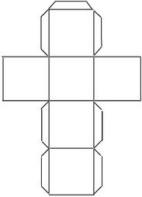

1 2 3 4

5 6

