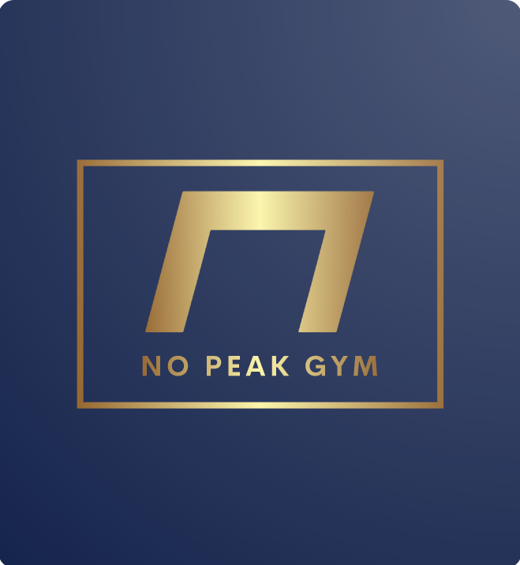
Registered Nurses, X-Ray Technicians, Certified Physicians and Therapists
Legal Consultation for NCAA /Professional Athletes
Diverse assortment of training staff and training equipment
Gender-inclusive
Mental Health Resources
Spa-like, Leisurely atmosphere
Community focused leadership
Total Body Rehabilitation
Layout structured around COVID-19
Suited for Professional and Recreational Athletes
Spacious exterior, conforms to natural landscape
Technology-Assisted Fitness
Research-backed Fitness Strategies

